**User’s guide - Match 3**

# **Table of Contents:**

1. How to start game
2. How to play
3. Earning points
4. How to play again

# **How to start game**

In the main menu, press the „Play game” buton.

# 

# **How to play**

In the Bejeweled (Match 3) game you must combine adjacent gems of the same color into three, four or five in vertical or horizontal lines to create „match” and score points.

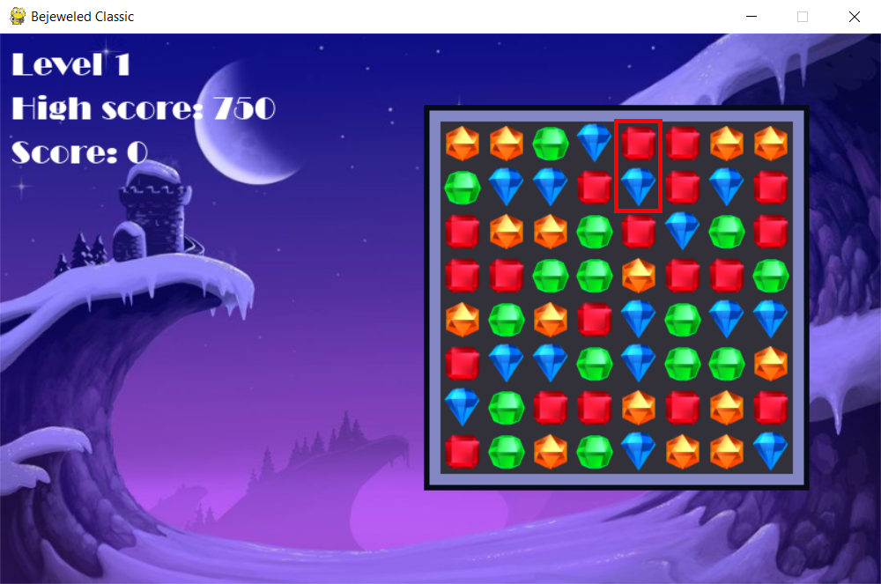To combine gems, you must select two jewels with the left-click.

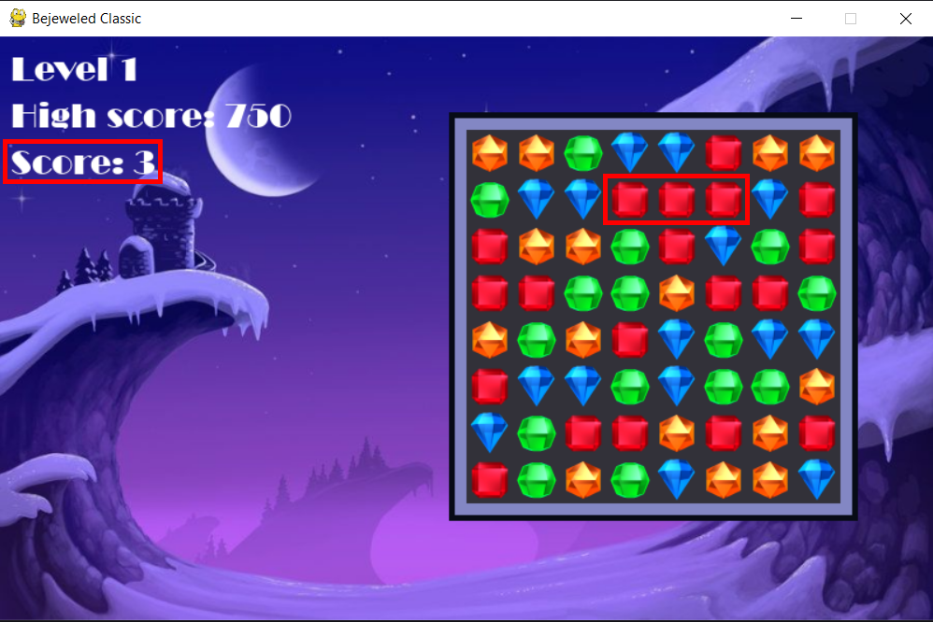If your combination is legal, it will be processed and you will score points.

# **Earning points**

3 points - 3-gems match  
4 points - 4-gems match  
5 points - 5-gems match

At the left-up corner of screen are shown: current level, high score and your actual score.  
When you break "level-score-limit", you will start next level, and you will have to score two times more points to go to the next one.

## **High score**

When you beat the current high score, you will be congratulated and your score will be saved.

# **How to play again**

The game ends when there is a layout on the board in which no combination of three or more gems is possible. You will be taken to the main menu. To play again, press the „Start” button.